Website Evaluation

* Data collected

1. Age group – 13 to 26 (more 18-26) 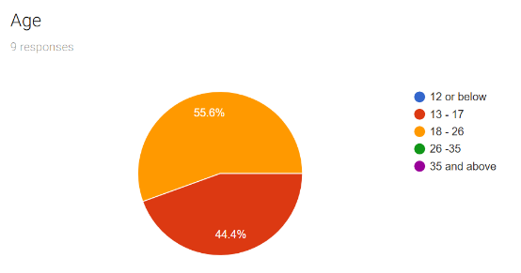
2. Gender-All male 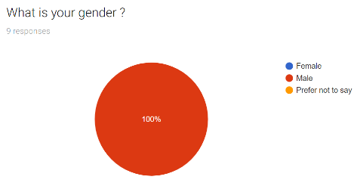
3. Features 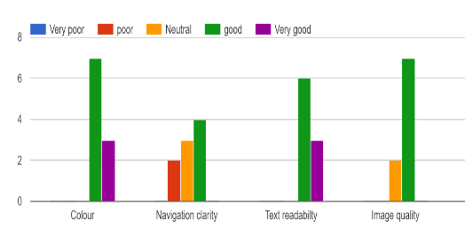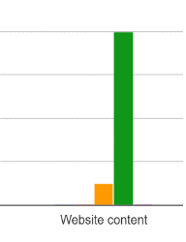
4. Interest 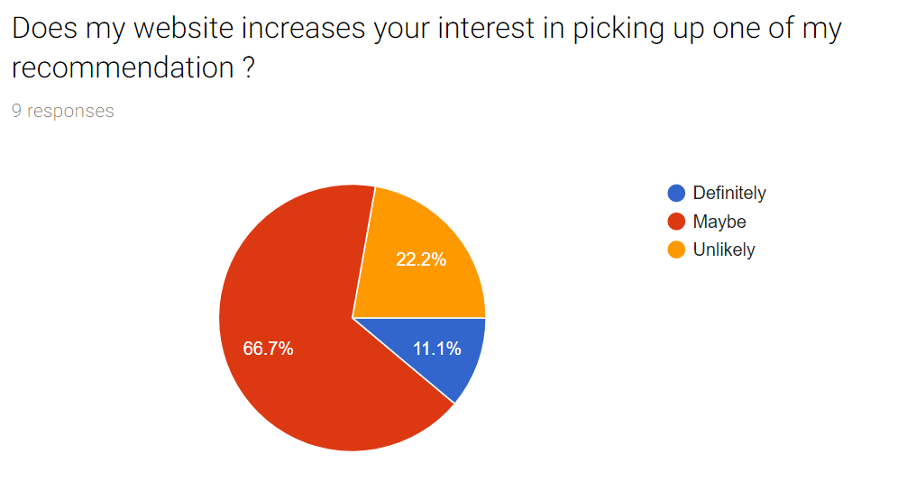
5. Overall Score -77.8%>7 11.1%>8 11.1%>1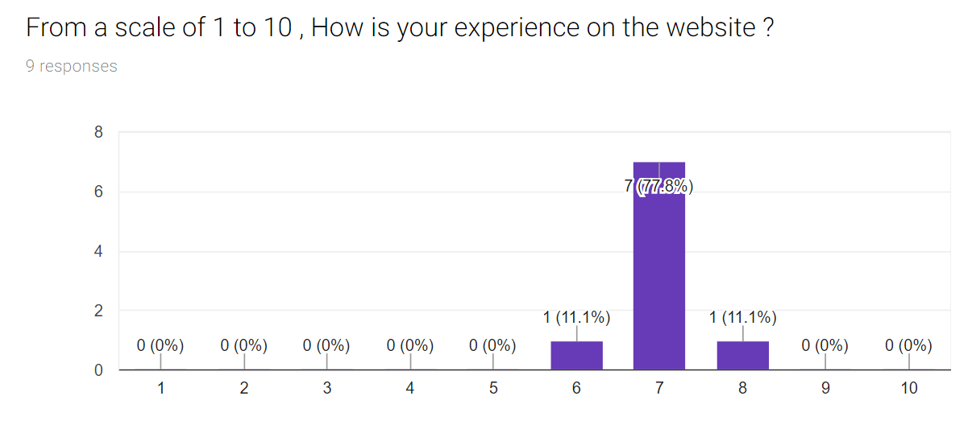

* Strength

From the data collected, colour, website content and text readability have a high “good” frequency with 3 person choosing the “very good” category for colour choice.

* Weakness

On the other hand, one of the main weaknesses of the website seems to be navigation. It has 2 person choosing “poor” and 3 choosing “neutral” and 4 choosing “good”. From the comment I collected it seems that the antique of putting the navigation bar below the home page bottom has backfired on me as it probably results in user not knowing if the navigation bar is a navigation bar as most website does not place the navigation bar at the bottom. Moreover, I have a different navigation bar for my other webpages that is affixed to the left that has images of home and a black and white arrow indicating that it will go to my other “Light” and “Dark” webpages I have, this pretentious move seems to also have backfire on me as some of the user seems to be weirded out but that fact but still understands what it means. There is also the fact the fact that one of the user feel that the logo placement in the middle is weird and one of them pointed out the fact that the website is not responsive yet and my profile picture looks odd.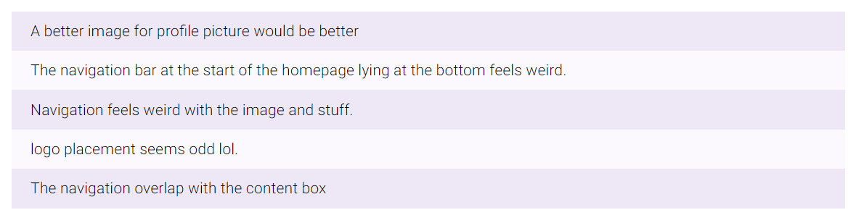

* Changes to be made for CA2

Aside from the requirement of having a responsive website for CA2. I would also scrap the whole “Dark” and “Light” navigation bar I have in the homepage and just have a navigation bar at the top of the website with the logo placement at the left for all webpages. I will also add a “:active” pseudo class as I did not have that at my navigation bar before to help user know where they are. The footer tag is only present at the Homepage on my CA1 website and that definitely is something that could be added to other homepage. I would also use a better image to express myself and a colour scheme more suited for my website. I also feel that some images is also not optimised well enough. Overall, my aim is to have the website look more normal and less pretentious than before.